# Required Components

|  |  |
| --- | --- |
| An assortment of components required for the sliding analog joystick assembly. These components are listed in the Bill of Materials (BOM) below. There are numbers beside each item.3D printed bottom of the enclosure.*An assortment of components required for the sliding analog joystick assembly. These components are listed in the Bill of Materials (BOM) below. There are numbers beside each item.* BOM | |
| 1. Mini 2-Axis Analog Thumbstick 2. Analog Mini Thumbstick Breakout Board with Included Male Headers 3. Universal Proto-Board PCB 4cm x 6 cm 4. SeeedStudio XAIO RP2040 with Included Male Headers 5. 24 Gauge Wire or Protoboard Jumper Wires | 1. 8x M2 x 6 mm Self Tapping Screws 2. USB-C Cable – 6 ft 3. 3D Printed Enclosure Top 4. 3D Printed Enclosure Bottom 5. 3D Printed Inner Disk 6. 3D Printed Overlay |
| Optional parts:  * 3D Printed Joystick Camera Mount Adapter * ¼-20 Tee Nut | * 2x M3 x 10mm Screws * 2x M3 Nuts |

# Required Tools

* Flush Cutters
* Wire Strippers
* Soldering Iron
* Philips Head Screwdriver
* (Optional for mount adapter) ¼-20 Screw or Hex Bolt, at least ½” long

# Required Personal Protective Equipment (PPE)

* Safety Goggles

# Assembly Instructions

## Step 1

|  |  |
| --- | --- |
| Place the 3D printed overlay on the protoboard.  **Ensure the text “MMC” is in the same orientation as the text on the protoboard.** | Universal protoboard PCB with a red 3D printed overlay on top. The overlay is thin and red and has holes in it for where components will be placed. The letters MMC are in the bottom left corner. |

## Step 2

|  |  |
| --- | --- |
| Place the two 7 pin male headers on the protoboard through the overlay and place the XIAO microcontroller board on the headers.  **Ensure the USB port on the XIAO is oriented towards the nearest edge on the protoboard.** | Protoboard with red overlay with XIAO microcontroller board placed in the top left corner. |

## Step 3

|  |  |
| --- | --- |
| Solder one pin on each of the headers to the protoboard, ensuring the XIAO microcontroller board remains flat and straight.  Note: the header pins from the XIAO board should be located at positions N08 – C14 and T08 – T14 (from below). | Bottom of the protoboard, showing the bottoms of the pins from the headers. Green circles indicate which two pins to solder. |

## Step 4

|  |  |
| --- | --- |
| Solder the remaining pins from the XIAO board to the protoboard. | Bottom of the protoboard, showing the bottoms of the pins from the headers. Green ovals indicate to solder remaining pins. |

## Step 5

|  |  |
| --- | --- |
| Insert the mini 2-axis analog thumbstick into the breakout board.  Solder the 6 pins, shown circled in red. | Close up of the joystick unit on the breakout board intended for use with standard headers.  Close up of the bottom of the joystick breakout board. The pads where the joystick pins go are circled in red.Close up of the bottom of the joystick breakout board. The pads where the joystick pins go have been soldered and are circled in red. |

## Step 6

|  |
| --- |
| Place the two 4 pin male headers on the protoboard through the overlay and place the joystick breakout board on the headers.  **Ensure the text on the breakout board is in the same orientation as the text on the overlay.** |
| Protoboard with overlay, showing male headers in their positions in the centre of the board. Protoboard with overlay, showing the joystick breakout board placed on top of headers in the middle of the protoboard. |

## Step 7

|  |  |
| --- | --- |
| Solder one pin on each of the headers to the joystick breakout board, ensuring the board remains flat and straight.  Note: the header pins from the XIAO board should be located at positions C06 - C09 and L06 – L09 (from below). | Bottom of the protoboard, showing the bottoms of the pins from the headers for the joystick board. Green circles indicate which two pins to solder. |

## Step 8

|  |  |
| --- | --- |
| Solder the remaining pins from the joystick breakout board to the protoboard. | Bottom of the protoboard, showing the bottoms of the pins from the headers. Green ovals indicate to solder remaining pins. |

## Step 9

|  |  |
| --- | --- |
| Flip the board around and remove the joystick breakout board and the XIAO board from the headers. | Protoboard with red overlay, and male headers in their positions. Microcontroller and joystick breakout board have been removed. |

## Wiring

For the next steps, this is the overall wiring diagram. 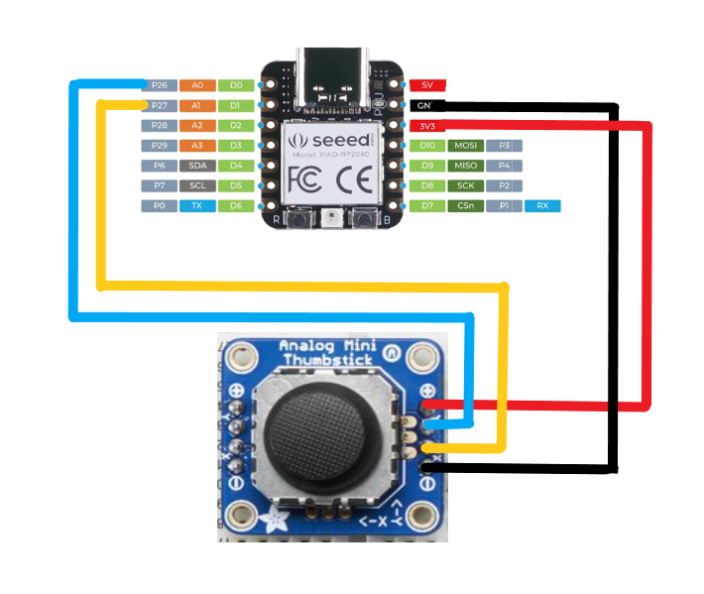

|  |  |
| --- | --- |
| **Seeed XIAO baord** | **Joystick breakout board** |
| 3v3 | + |
| GND | - |
| D0 | Y |
| D1 | X |

## Step 10

|  |  |
| --- | --- |
| Insert a wire from hole M12 to hole K09.  NOTE: All hole positions are in reference to the bottom of the board. | Bottom of the protoboard showing the placement of a yellow wire, with the ends of the wire circled in green. |

## Step 11

|  |  |
| --- | --- |
| Solder the wire in place and create solder bridges from the wire ends to the adjacent pins. From M12 to N12, from K09 to L09. | Bottom of the protoboard showing that the ends of a yellow wire are now soldered. The ends of the wire are circled in green. |

## Step 12

|  |  |
| --- | --- |
| Insert a wire from M13 to K06.  Solder the wire in place and create solder bridges from the wire ends to the adjacent pins. From M13 to N13 and from K06 to L06. | Bottom of the protoboard showing the placement of a white wire, with the ends of the wire circled in green. |

## Step 13

|  |  |
| --- | --- |
| Insert a wire from S14 to D08.  Solder the wire in place and create solder bridges from the wire ends to the adjacent pins. From S14 to T14 and from D08 to C08. | Bottom of the protoboard showing the placement of a red wire, with the ends of the wire circled in green. |

## Step 14

|  |  |
| --- | --- |
| Insert a wire from S13 to D07.  Solder the wire in place and create solder bridges from the wire ends to the adjacent pins. From S13 to T13 and from D07 to C07. | Bottom of the protoboard showing the placement of a second red wire, with the ends of the wire circled in green. |

## Step 15

|  |  |
| --- | --- |
| On the bottom of the board, trim the header pins for both the joystick board and the XIAO board, as shown circled in green. | Close up of the protoboard showing the long header pins on the bottom of the board. These pins are circled in green.  Close up of the protoboard showing the long header pins on the bottom of the board, and indicating where to cut them with a green dashed line. |

## Step 16

|  |  |
| --- | --- |
| On the top of the board, trim the extra length from the jumper wires, as shown circled in green.  **Do no trim the male headers on the top of the board.** | Close up of the protoboard from the side view, showing the long wires sticking out on the top of the board. These wires are circled in green.  Close up of the protoboard showing the long wires sticking out on the top of the board. Dashed lines show where to cut the wires. |

|  |
| --- |
| Below is how the board should look once the wires and bottoms of headers are trimmed. |
| Close up of the bottom of the protoboard with all of the wires solders and headers trimmed.  Close up of the top of the protoboard with male headers in their positions and wires trimmed. |

## Step 17

|  |  |
| --- | --- |
| If you wish to re-use the 3D printed overlay you may remove it, or it may be left on.  Place the XIAO microcontroller board and the joystick breakout board onto their respective headers.  **Ensure the USB port on the XIAO is oriented towards the nearest edge on the protoboard.**  **Ensure the text on the joystick board is in the same orientation as the text on the overlay/protoboard.** | Top of the protoboard with red overlay, and with microcontroller and joystick breakout board in their positions but not soldered. |

## Step 17

|  |  |
| --- | --- |
| Solder the XIAO microcontroller board and the joystick breakout board to their headers.  Ensure the boards stay flat while soldering. | Top of the protoboard with red overlay, and with microcontroller and joystick breakout board in their positions and soldered. Green ovals show where to solder. |

## Step 18 – Optional

If mounting the joystick (not using on a tabletop) and using a mount adapter, take the two M3 nuts and slide them into the slots inside the enclosure as shown.

|  |  |
| --- | --- |
| Bottom of sliding joystick enclosure, showing two M3 nuts beside the nut slots, with two red arrows indicating the direction to slide the nuts into the slots. | Bottom of the sliding joystick enclosure, showing two nuts in the nut slots. Two red circles show the locations of the nuts. These are used for mounting. |

## Step 19

|  |  |
| --- | --- |
| Take the protoboard and the bottom of the 3D printed enclosure and insert M2 screws in each of the four corners of the board, as shown circled in red. | Protoboard installed in the bottom of the 3D printed enclosure. Red circles show the locations of the screw holes. |

## Step 20

|  |  |
| --- | --- |
| Remove the joystick topper.  Place the 3D printed inner disk on the joystick, around the joystick post.  Replace joystick topper. | Close up of the joystick unit without the joystick topper. Close up of the joystick unit without the joystick topper. A black disk has been placed on the joystick peg. Close up of the joystick unit with the joystick topper and black disk. |

Note: if the joystick is difficult to move after this step, sand down the inner cover disk so it is smooth and does not have bumps or zits.

## Step 21

|  |  |
| --- | --- |
| Place the 3D printed enclosure lid on top of the enclosure base. | Top view of the joystick, with the top of the enclosure installed. |

## Step 22

|  |  |
| --- | --- |
| Flip the joystick around and insert an M2 screw into each of the 4 screw holes circled in red and tighten them. | Bottom of the 3D printed enclosure, with red circles showing the locations of the screw holes. |

## Step 23

|  |  |
| --- | --- |
| Plug the USB C cable into the joystick, and proceed to programming the joystick. | Top view of the joystick, with the USB C cable plugged into it. |

# Programming instructions

1. Setup Arduino IDE
   1. Download Arduino IDE for your operating system at <https://www.arduino.cc/en/software>
   2. Install Arduino IDE
2. Setup Core
   1. Open Arduino IDE
   2. Click on **File -> Preferences**
   3. Locate the text field that says **Additional Boards Manager URLs** beside it.
   4. Copy and paste the following link into the field as a new line: <https://github.com/earlephilhower/arduino-pico/releases/download/global/package_rp2040_index.json>

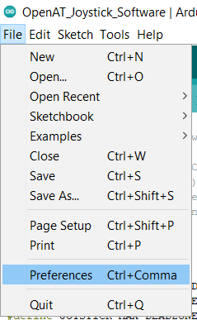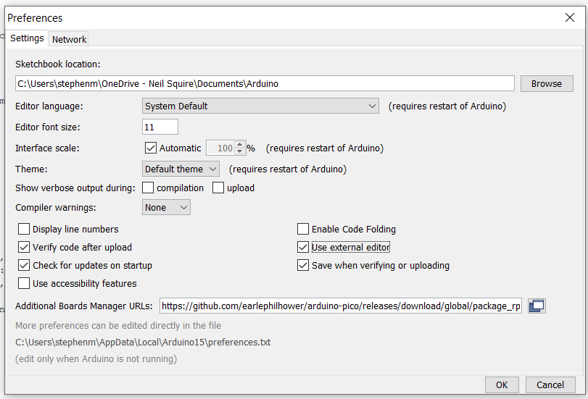

* 1. Click on **OK**
  2. Restart the Arduino IDE
  3. Open the **Boards Manager** option from the **Tools-> Board-> Boards Manager..., search for “Seeed Xiao” and select the package called “Raspberry Pi Pico/RP2040” by Earle F. Philhower, III**

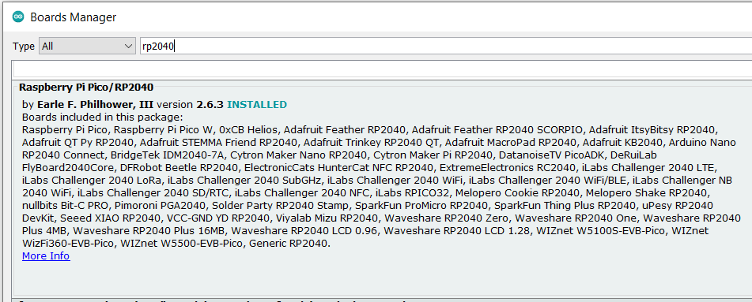

* 1. Select **Seeed XIAO RP2040** from **Tools -> Board** **-> Raspberry Pi RP2040** **Boards** menu.

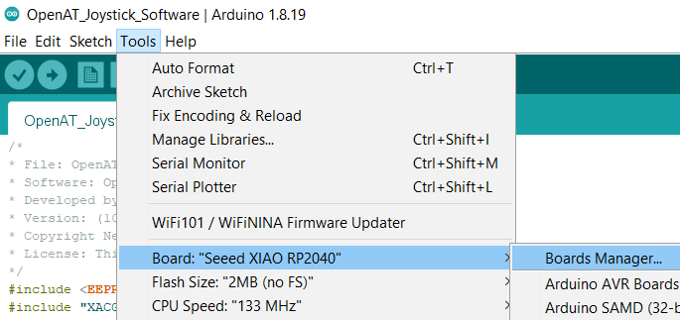

* 1. Click on **Tools -> USB Stack** and select **Adafruit TinyUSB**

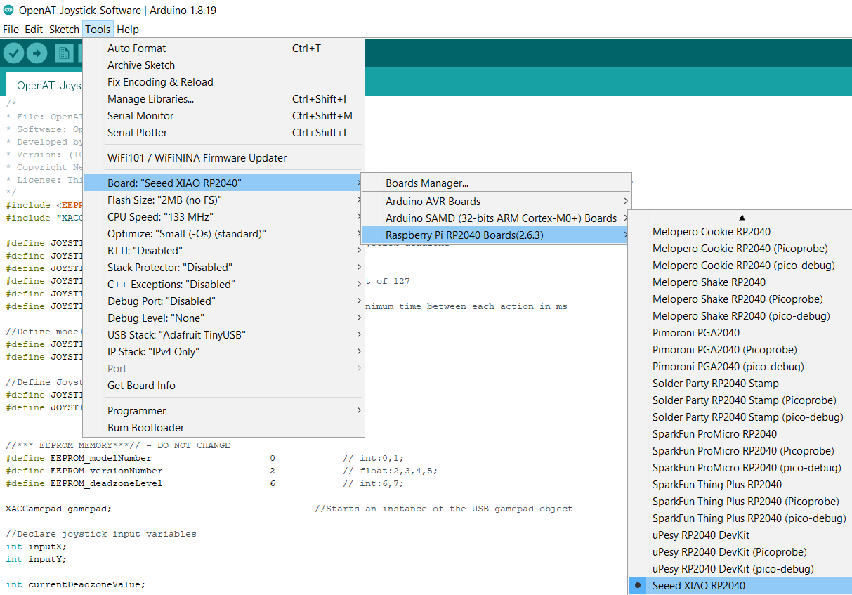

More Information: <https://wiki.seeedstudio.com/XIAO-RP2040-with-Arduino/>

1. Upload the Code to the joystick
   1. Open OpenAT_Joystick_Software_Birch.ino with Open Arduino ID.
   2. Select **Seeed XIAO RP2040** from **Tools -> Board** **-> Raspberry Pi RP2040** **Boards** menu.
   3. Connect the joystick using the USB cable to the computer.
   4. Select the correct port from **Tools -> Port** menu.
   5. Verify and upload the code.

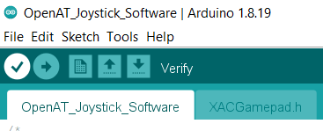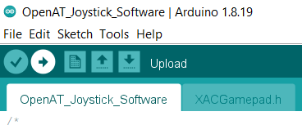

# Testing

1. Connect the joystick using the USB C cable to the computer.
2. If using Windows, open “Set up USB Game Controllers” from the Control Panel. You can find this by searching your computer in the search bar next to the Windows icon.
3. Ensure that the joystick is registered as a game controller and select your joystick from the list and go to “Properties”.
4. Move your joystick and observe the movement of the cross hatch in the “Axes” window. Ensure it moves in the proper directions when you move the joystick (the arrow points in the up direction). If not, open the joystick and check your connections.

# Optional – Mounting

## Table Top Mounting – Non-Slip Pads

|  |  |
| --- | --- |
| If using the joystick on a tabletop, and height of the joystick is not a concern, nonslip pads can be added in each of the four corners on the bottom, as shown. |  |

## Table Top Mounting – Hook and Loop Fastener

|  |  |
| --- | --- |
| If using the joystick on a tabletop or other surface with hook and loop fasteners, such as Velcro, stick the hook side (rough side) to the joystick and the loop side (soft side) to the surface to mount to. | Bottom of the joystick with hook and loop fastener attached to the bottom. The hook side is shown stuck to the joystick. |

## Camera Mount

To mount the joystick on a camera mount, the optional Joystick Camera Mount Adapter can be used.

|  |  |
| --- | --- |
| Step 1 Flip the camera mount adapter around to reveal the recess with small slots.  Ensure all supports are removed from the 3D print. | Blue 3D printed part for the camera mount adapter. There are two holes on the sides and one hole in the middle with small slots around it. |

|  |  |
| --- | --- |
| Step 2 Insert the tee nut, lining up the barbs with the small slots in the 3D print. | Blue 3D printed part for the camera mount adapter, with a tee nut sitting inside of it, not fully inserted. |

|  |  |
| --- | --- |
| Step 3 Flip the part around and screw in a ¼-20 hex bolt. | Blue 3D printed part for the camera mount adapter, with a hex bolt being screwed into it. There is a white arrow showing to screw in the hex bolt clockwise. |

|  |  |
| --- | --- |
| Step 4 Tighten the bolt until the tee nut is seated down as far as possible.  (Alternatively, if you do not have acces to a bolt, the tee nut may be press fit as long as it sits flush with the 3D print.) | Top of the camera mount adapter, with a hex bolt fully screwed into it. There is a white arrow showing to screw in the hex bolt clockwise. Bottom of the camera mount adapter, showing a tee nut fully installed into the 3D print, and sitting flush. There are two arrows pointing down to indicate that the tee nut is all the way down. |

|  |  |
| --- | --- |
| Step 5 Using 2 M3 screws, screw the camera mount adapter to the bottom of the joystick in the two middle holes. | The camera mount adapter screwed into the bottom of the Sliding Analog Thumbstick, using two small screws. Both the camera mount adapter and the joystick are light blue. The screws are circled in red. |